**PLSQL Exercise**

**Exercise 3: Stored Procedures**

**Scenario 1:** The bank needs to process monthly interest for all savings accounts.

* + **Question:** Write a stored procedure **ProcessMonthlyInterest** that calculates and updates the balance of all savings accounts by applying an interest rate of 1% to the current balance.

**SAVINGS_ACCOUNT Table**

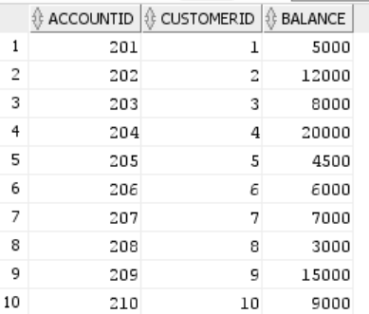

**EMPLOYEES Table**

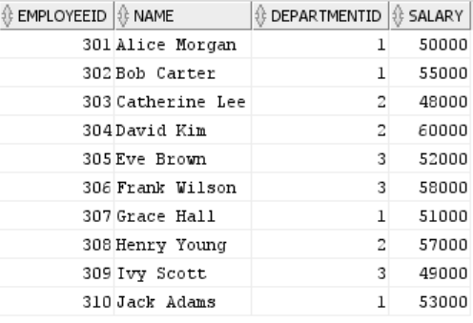

**ACCOUNTS Table**

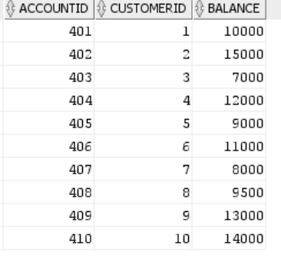

**Code:**

CREATE OR REPLACE PROCEDURE ProcessMonthlyInterest AS

BEGIN

UPDATE SAVINGS_ACCOUNTS

SET Balance = Balance + (Balance * 0.01);

COMMIT;

DBMS_OUTPUT.PUT_LINE('Monthly interest applied to all savings accounts.');

END;

/

**Output:**

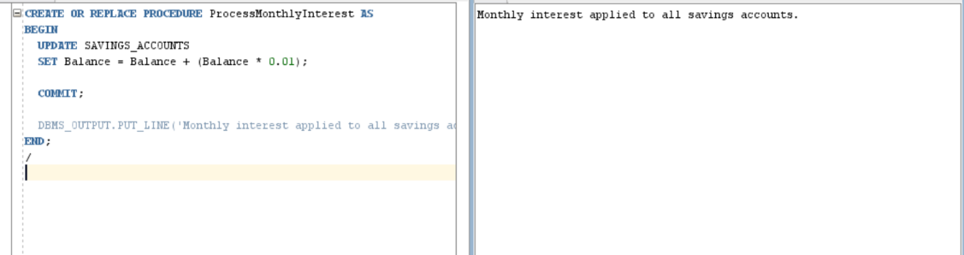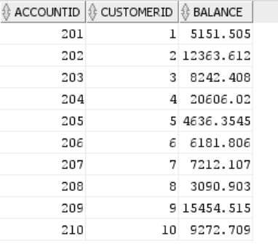

**Scenario 2:** The bank wants to implement a bonus scheme for employees based on their performance.

* + **Question:** Write a stored procedure **UpdateEmployeeBonus** that updates the salary of employees in a given department by adding a bonus percentage passed as a parameter.

**Code:**

CREATE OR REPLACE PROCEDURE UpdateEmployeeBonus (

p_DepartmentID IN NUMBER,

p_BonusPercent IN NUMBER -- e.g., pass 10 for 10%

) AS

BEGIN

UPDATE EMPLOYEES

SET Salary = Salary + (Salary * p_BonusPercent / 100)

WHERE DepartmentID = p_DepartmentID;

COMMIT;

DBMS_OUTPUT.PUT_LINE('Bonuses applied to employees in department ' || p_DepartmentID);

END;

**Output:**

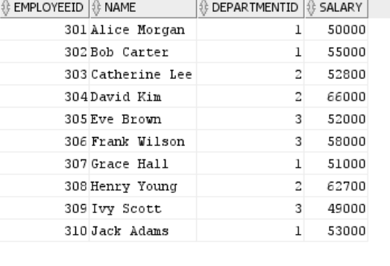

**Scenario 3:** Customers should be able to transfer funds between their accounts.

* + **Question:** Write a stored procedure **TransferFunds** that transfers a specified amount from one account to another, checking that the source account has sufficient balance before making the transfer.

**Code:**

CREATE OR REPLACE PROCEDURE TransferFunds (

p_FromAccountID IN NUMBER,

p_ToAccountID IN NUMBER,

p_Amount IN NUMBER

) AS

v_SourceBalance NUMBER;

BEGIN

-- Get source account balance

SELECT Balance INTO v_SourceBalance

FROM ACCOUNTS

WHERE AccountID = p_FromAccountID

FOR UPDATE; -- Lock row for update

IF v_SourceBalance < p_Amount THEN

RAISE_APPLICATION_ERROR(-20001, 'Insufficient balance in source account.');

END IF;

-- Deduct from source

UPDATE ACCOUNTS

SET Balance = Balance - p_Amount

WHERE AccountID = p_FromAccountID;

-- Add to destination

UPDATE ACCOUNTS

SET Balance = Balance + p_Amount

WHERE AccountID = p_ToAccountID;

COMMIT;

DBMS_OUTPUT.PUT_LINE('Transferred ' || p_Amount || ' from account ' || p_FromAccountID || ' to account ' || p_ToAccountID);

END;

/

call TransferFunds(401,402,500);

**Output:**

